**Fault to One-Line Diagram**



**Javier Jesús Macossay-Hernández**

**EE443 – Introduction to Power Systems**

**University of Southern California**

**Professor Robert Castro**

**Objective**

In power engineering, fault current is a current that passes through a short circuit where it avoids the normal load. The analysis of a fault in the following circuit will allow deriving an equivalent one-line diagram consisting of a generator, two transmission lines, and three transformers. On Design Case 2, the fault has been simulated on HOMER69 bus.

**Introduction**

The area that will be analyzed is HOMER69, shown in Fig. 1 and Fig. 2. This bus has two inputs and a 14 MW/ 3 MVAR load attached to it.

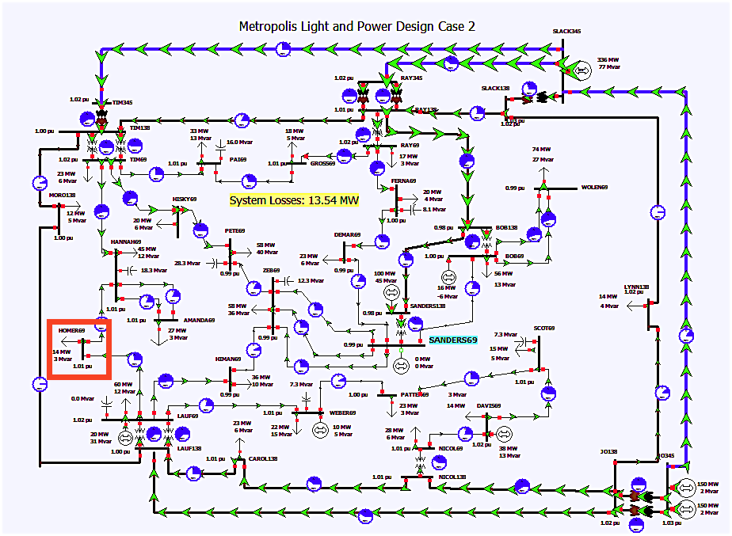

Fig. 1: The overall schematic of the circuit is shown, where HOMER69 bus is highlighted.

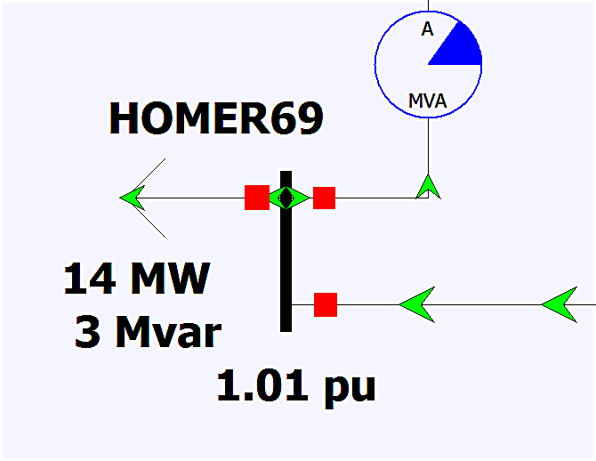

Fig. 2: HOMER69 bus

**Methods**

PowerWorld’s “Fault Analysis Tool” located in the “Tools” tab, shown in Fig 3, will be needed to analyze the fault that has been created in this bus.

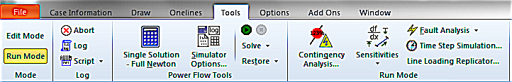

Fig. 3: Fault Analysis Tool

The fault will be created by selecting HOMER69 in the “Single Fault” drop-down tab. “Fault Location” needs to be set to “Bus Fault” and “Fault Type” will be set to “3 Phase Balanced.” Finally, press the “Calculate” button, as shown in Fig. 4.

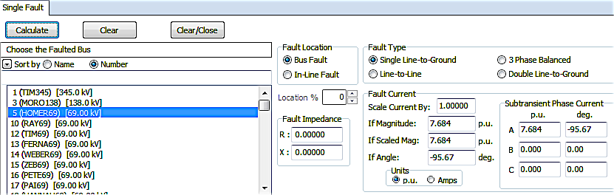

Fig. 4: Fault Current in Per Unit Form

As shown in Fig. 4, the fault placed on HOMER69 will have as a result a per unit fault current of If = 7.684 pu. The units of the fault current can be converted from per unit to Amperes by selecting “Amps” in the “Fault Current Units” field. In Fig. 5, the fault current is If = 6,429.72 A = 6.42972 kA.

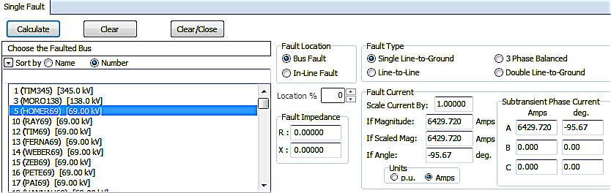

Fig. 5: Fault Current in Ampere Form

The per unit value of the voltage needs to be determined to create the per unit impedance diagram. The HOMER69 bus is rated for 69 kV, but it is operating at 69.73 kV, as shown in Fig. 6.

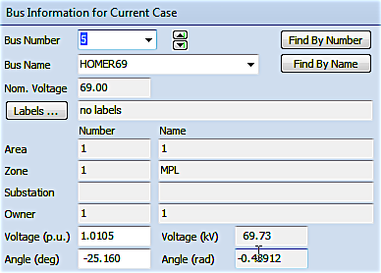

Fig. 6: “Bus Information Dialog” box shows the operating voltage of HOMER69.

**Calculations**

The per unit voltage, Vpu, can be calculated by dividing the operating voltage, Vop, by the rated voltage, Vr.

*V pu = $\frac{Vop}{Vr}$ = $\frac{69.73 kV}{69 kV}$ = 1.01 pu*

The total impedance of the circuit, Xtotal, can be calculated by diving Vpu by the fault current, If, previously calculated.

*Xtotal = = = 0.131 j pu*

The impedance diagram, Fig. 7, for the circuit fault can be created with known values for Vpu, If, and Xtotal.

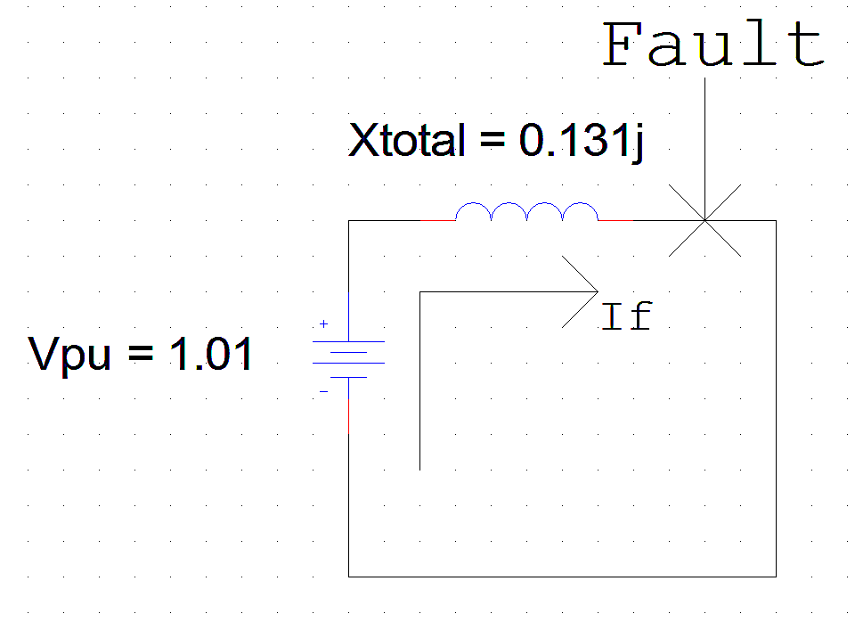

Fig. 7: Fault and Fault Current shown in the Impedance Diagram

Xtotal can be viewed as the sum of the impedances of the generator, Xg, of the transmission line, Xt/l, and of two transformers, Xt1 and Xt2.

*Xtotal= Xg + Xt1 + Xt2 + Xt/l.*

Because no specifications are given on the weight of each of these impedances on the total impedance, there is freedom in the process of designing the system. To determine the weight each term should be given, intuition can be used. Typically, transmission line impedances are smaller than generator impedances and transformer impedances; therefore, the latter can be given more weight. Additionally, it can be assumed that each of the two transformers have equal impedances in the form Xt1=Xt2.

In this example, Xtotal is distributed as follows:

Xg = 0.3 x Xtotal = 0.3 x 0.131 j = 0.039 j pu

Xt/l = 0.2 x Xtotal = 0.2 x 0.131 j = 0.026 j pu

Xt1 = Xt2 = 0.25 x Xtotal = 0.25 x 0.131 j = 0.033 j pu

These values can be used to expand out Xtotal in the above closed-circuit, as shown below.

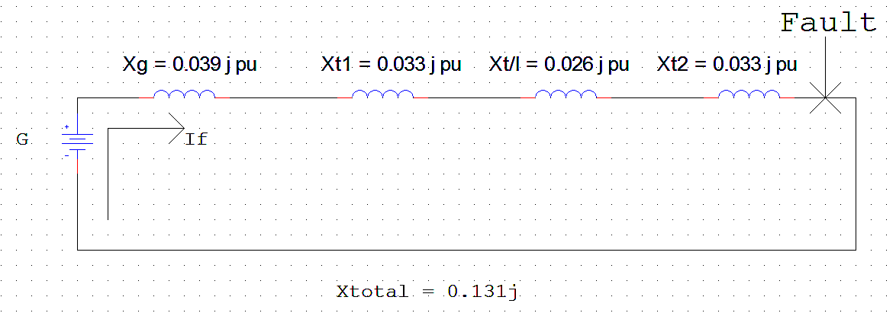

Fig. 8: Closed-Circuit with Distributed Xtotal

The circuit can be reverse-engineered to fin an equivalent one-line diagram. In order to do this, zoning can be used to split the circuit into three zones, separated by the two transformers. “Zone 1” will range from the generator to the first transformer, “Zone 2” will range between the two transformers (including the transmission line impedance), and “Zone 3” will range from the second transformer to the fault.

According to this arrangement, the fault takes place after the second transformer, in the third zone of the circuit. Using the “Fault Analysis Tool” in PowerWorld, the values of current and voltage for the fault have been calculated.

The voltage at the fault is equal to the voltage at the HOMER69 bus.

Vb3 = Base voltage of Zone 3 = Vop = 69.73 kV

Ib3 = Base current of Zone 3 = If / Ipu = 6,429.72 / 7.684 = 836.767 A

Using these two parameters, the MVA base for the third zone can be calculated.

Sb3 = Base MVA of Zone 3 = $\sqrt{3}$

x Vb3 x Ib3 = 101.06 MVA

As the MVA is 101.06 MVA kept constant across the system, the other system parameters can be calculated using this information. Nevertheless, some additional parameters must be defined.

The generator will be set at 101.06 MVA, with a 14 kV operating voltage.

Transformer 1 will be rated for 90 MVA, 14 kV / 235 kV.

Transformer 2 will be rated for 90 MVA, 235 kV / 69 kV.

The transmission line will have an impedance of 0.8 ohms / mile.

The base impedance from “Zone 3” can be calculated using these values.

Zb3 = [(Vb3)2] / Sb3 = 69.732 / 101.06 = 48.1127 ohms

The relevant base parameters from “Zone 2,” found by using the constant MVA base and converting the base voltage from “Zone 3” through Transformer 2 are as follow:

Sb2 = Sb3 = 101.06 MVA

Vb2 = (69.73 kV x 235) / 69 = 237.486 kV

Ib2 = Sb2 / ( x Vb2) = 245.686 A

Zb2 = (Vb2)2 / Sb1 = 558.08 ohms

The relevant base parameters from “Zone 1,” found by using the constant MVA base and converting the base voltage from “Zone 3” through Transformer 1 are as follow:

Sb1 = Sb2 = 101.06 MVA

Vb1 = Vb2 x 14 kV/ 235 = 14.15 kV

Ib1 = Sb1 / ( x Vb1) = 4123.46 A

Zb1 = (Vb1)2 / Sb1 = 1.98 ohms

To calculate the correct impedance values to use in the one-line diagram, the following formula is used:

Xold = Xnew x (MVAold / MVAnew) x [(Vnew / Vold)2] .

The old impedances are the following:

Xgold = (0.039 j pu) x (14.15 / 14)2 = 0.0398 j pu

Xt1old = 0.033 j pu x (90 / 101.06) x [(237.486 kV / 235 kV)2] = 0.03 j pu

Xt2old = 0.033 j pu x (90 / 101.06) x [(69.73 kV / 69 kV)2] = 0.03 j pu

Xt/lactual = Xt/lold x Zb2 = 0.026 j x 558.08 = 14.51 j ohms

L = t/l length = Xt/lactual / 0.8 ohms/mile = 18.138 miles

**Results**

Using the information in the previous section, a one-line equivalent for the closed-circuit above can be created, achieving the goal of transforming a fault into a circuit with a generator, transmission line, and two transformers.

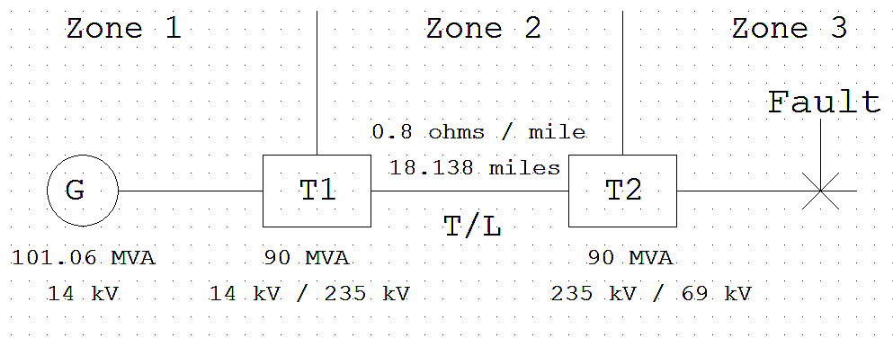

Fig. 9: The Final One-Line Equivalent Length Fault Diagram

**Discussion**

This problem involved the creation of a circuit from a fault using initial information calculated by PowerWorld in order to build a framework for an equivalent one-line diagram designated to incorporate several specific circuit elements.

Results after that are not directly mentioned as they involved making assumptions and choosing arbitrary values to circuit elements. By using these, the corresponding one-line diagram that contains all the specified circuit elements was developed.

The amount of work needed to solve this problem would be much greater had it not been for the usage of PowerWorld’s “Fault Analysis Tool.” Because the tool calculated the fault current at the bus, it would have to be directly calculated in the absence of the tool; this can easily give way to human error due to the size of this power system. Because PowerWorld can analyze a fault quickly, it is much more time-efficient to use this tool. This, then, becomes an example of the usage of PowerWorld in scenarios other than in a classroom setting, giving a better understanding on Fault analysis.